GDOW KIDS
Name
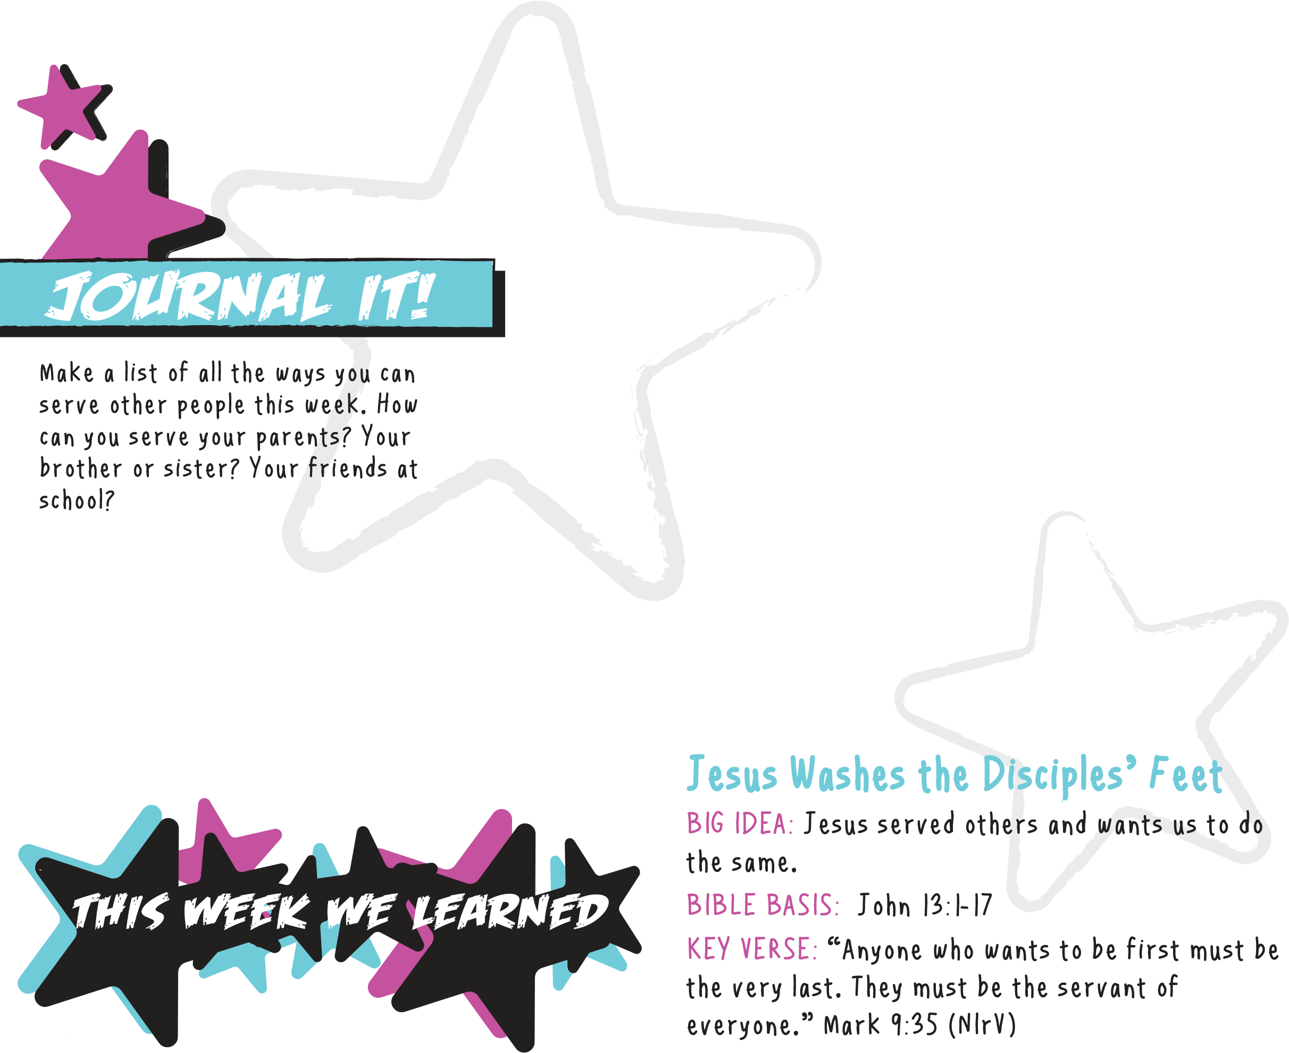
Date
DRAW IT!
Draw a picture of one way you can serve someone this coming week.

READ IT!
John 13:1-17. Draw a picture of the story or write to God your favorite part of the story. Tell Him why you liked it.
serve others and put them first this week.
Write a prayer to God. Ask Him
to show you some ways to
PRAY IT!
NEXT WEEK’S LESSON
Th
e
Last Su
p
p
e
r
BIG IDEA:
Jesus gave His body and blood for our sins, so
we can remember Him through communion.
BIBLE BASIS: Matthew 26:17-30; Luke 22:7-30
KEY VERSE: “Everyone should take a careful look at themselves before they eat the bread and drink from the cup.” 1 Corinthians 11:28 (NIrV)

