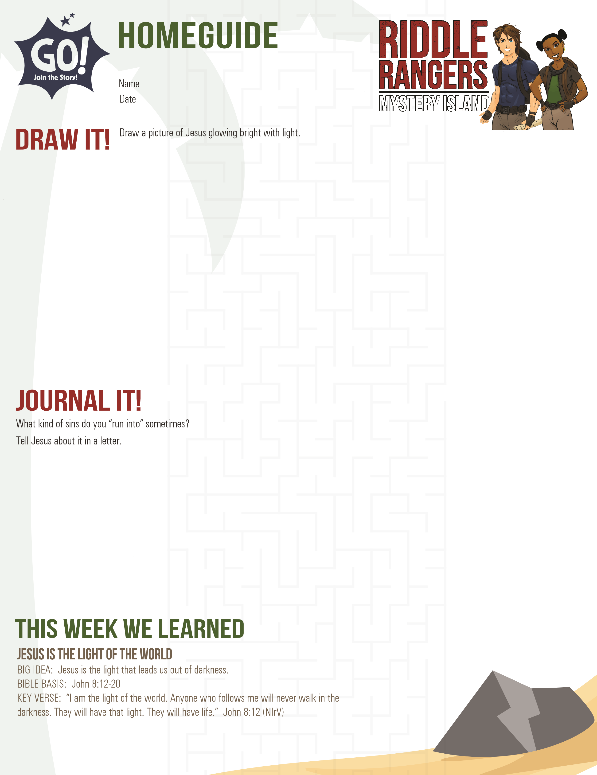



PRAY IT!

READ IT!

NEXT WEEK’S LESSON

Jesus is the light of the world. Write a prayer asking Him to help you.

you avoid sin.

John 8:12. Draw a picture of the verse or write to God what you

like best about that verse.

Jesus is the Way, Truth, and Life

**BIG IDEA: Jesus is the one true God and following Him is the only way to**

**eternal life.**